Task: Data Analysis

**1A. In what city Fond Rouge loses the highest % revenue due to returns?**(Where the ratio refund:revenue is the highest?)

Answer) San Diego

**1B. Paste a screenshot of your Stacked Bar chart of Revenue & Refund per US city.**

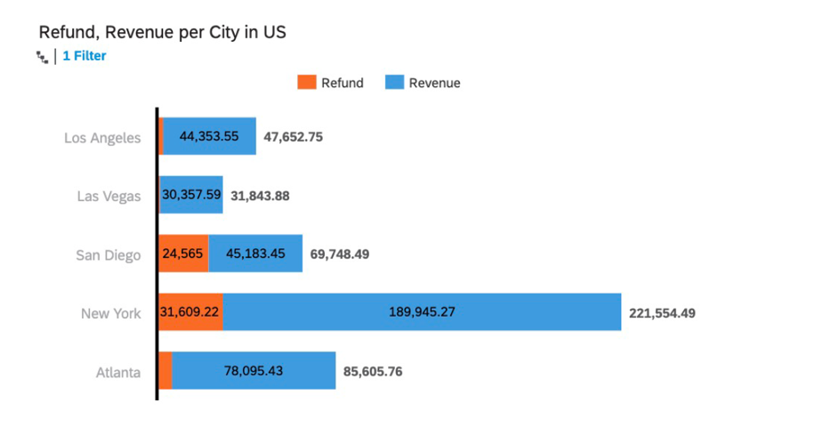

**2A. What is the % NEG Class-ifiers in the US?**  
((Number of all sales with Sentiment Class=NEG in the US) / (Number of all sales in the US) * 100)

Answers) 31.46%

**2B. Paste a screenshot of your Donut chart of Sentiment Class in the US**

**Answer)**

**3A. What is the % NEG Class-ifiers, Globally?**  
((Number of all sales with Sentiment Class=NEG) / (Number of all sales) * 100)

Answer)

4.51%

**3B. Paste a screenshot of your Donut chart of Sentiment Class, Globally.**

**Answer)**

**4A. List the locations where counterfeiting may be happening?**(Hint: look for cities where the returns are lower than 20%, but the Sentiment is low (under 65))

Answer) Los Angeles and Las Vegas

**4B. Paste a screenshot of your Column & Line chart of Refund/Revenue & Avg Sentiment per US city.**

**5. Does Fond Rouge have a problem in all of its American locations? How can you tell?**

Only San Diego, low sentiment and drop revenue.

**6. Is counterfeit the only problem that’s observable in Fond Rouge’s data for its US operation? Why?**

Hard to tell as need more relevant data on this.

**7. Paste a screenshot of your GeoMap (Bubble Layer) of Location, Avg Sentiment, Revenue.**

**8. Paste the login url for your SAP Analytics Cloud tenant.**https://guided-experience-sac-ap11.cfapps.ap11.hana.ondemand.com/sap/fpa/ui/app.html?#/story2&/s2/2DAAD9005C85898E12CB35A39919B583/?type=CANVAS&mode=edit